**ST.XAVIER’S COLLEGE**

MAITIGHAR, KATHMANDU



Database Management System

Assignment #7

Submitted By:

Aabhash Dhakal

013BSCCSIT001

2nd year/ 4th semester

Submitted to:

|  |  |
| --- | --- |
| Er. Sanjay Kumar Yadav  Lecturer  Department of Computer Science |  |

1. Selection
2. Combining conditions and boolean operations
3. Removing Duplicates
4. Range Specifications
5. String operations
   1. ABC% : All strings that start with ABC. Eg. ABCD, ABCABC; both satisfy the condition.
   2. %XYZ : All strings that end with XYZ. Eg. WXYZ, ZZXYZ; both satisfy the condition.
   3. %AN% : All strings that contain the pattern AN anywhere. Eg. LOSANGELES and SAN FRANCISCO.

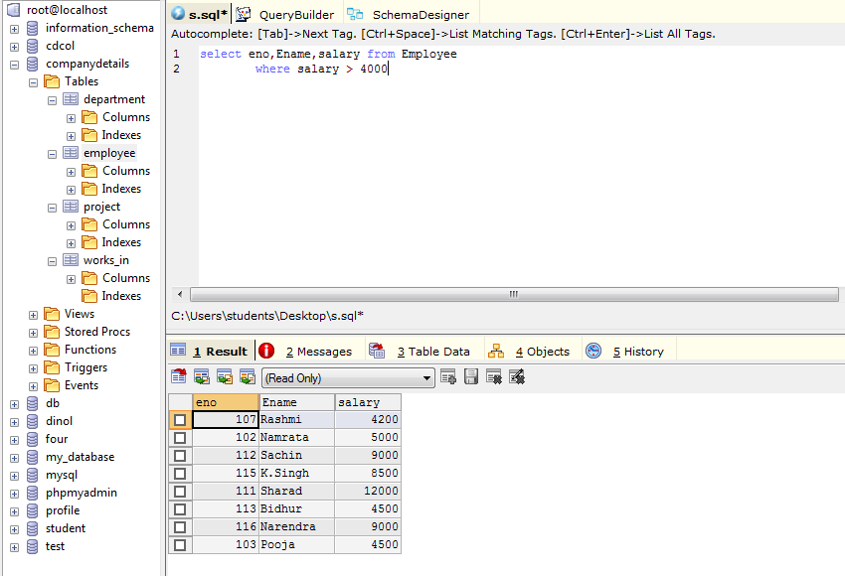

Find the eno, ename of the employee whose salary is greater than 4000.

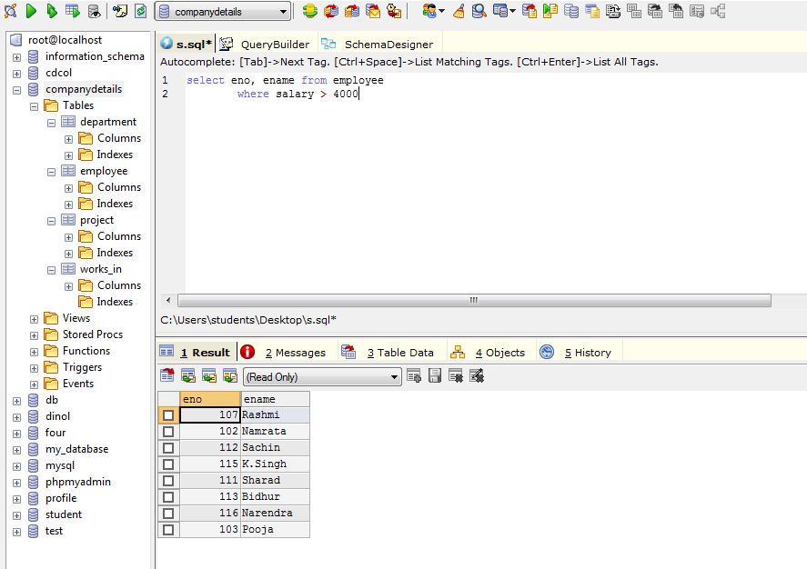

Find the eno, ename, salary of the employees whose salary is greater than 5000 and job status is professor.

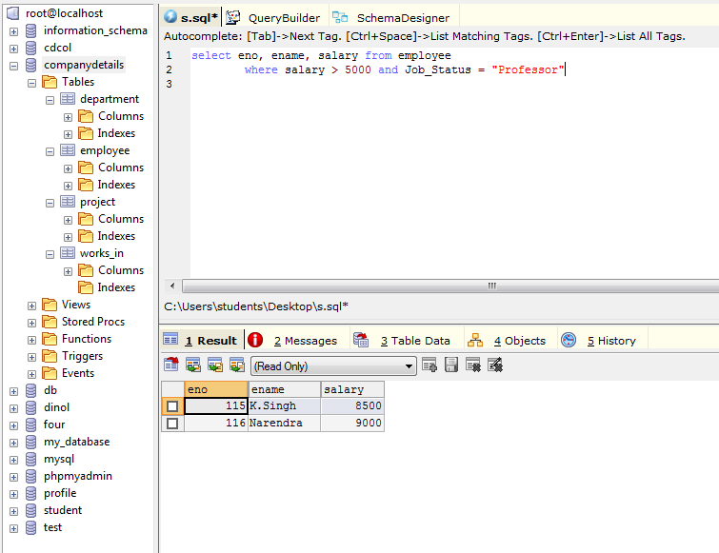

Selection Of Address:

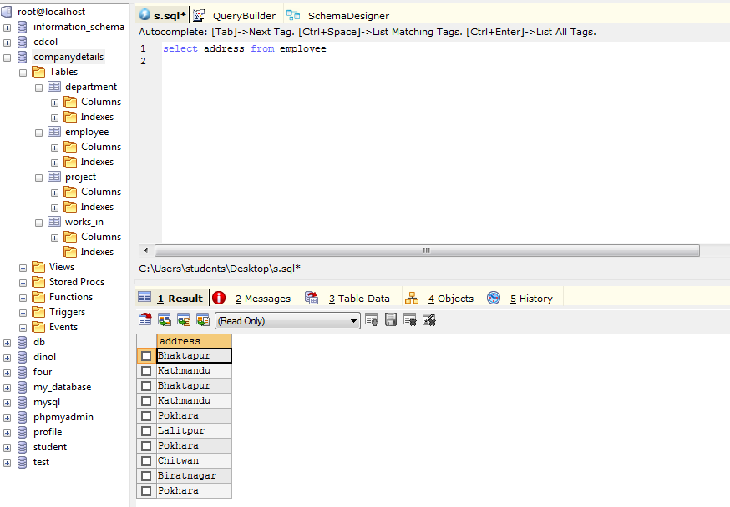

No Duplication:

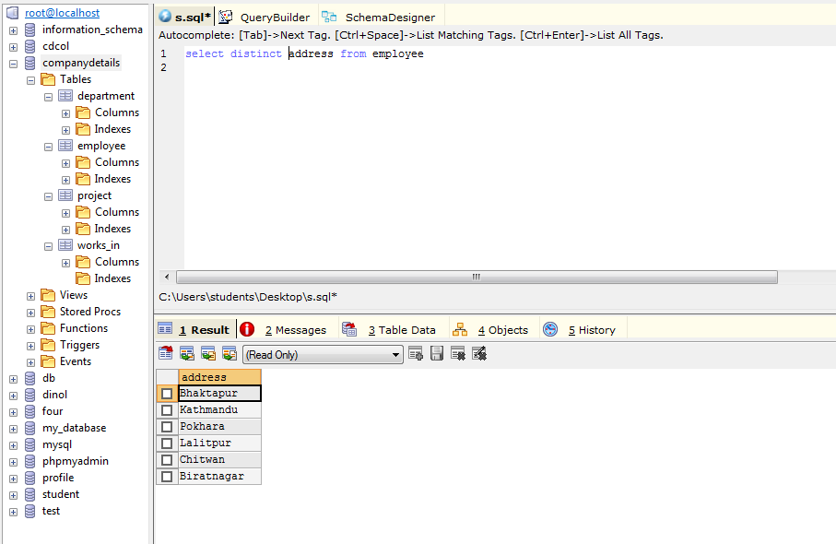

Find the eno, ename, salary of the employees whose department number is 20 or job status is research fellow.

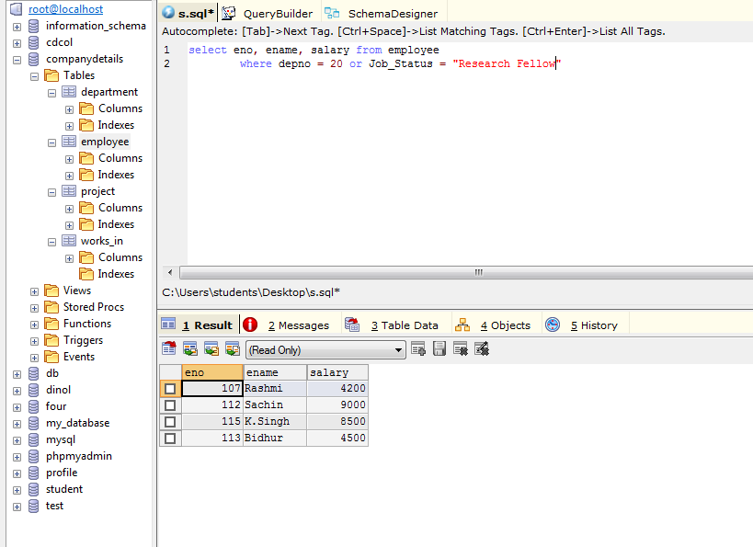

Find the eno, ename, age and salary from the employees where the age is between 24 & 28.

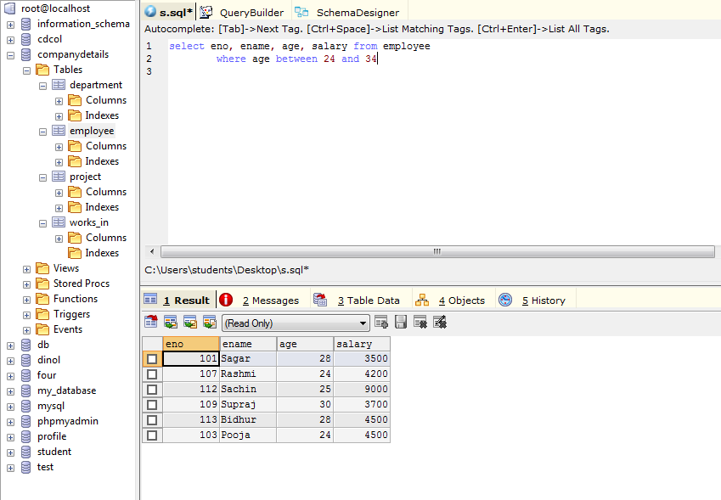

Find eno, ename whose starting letter is SA.

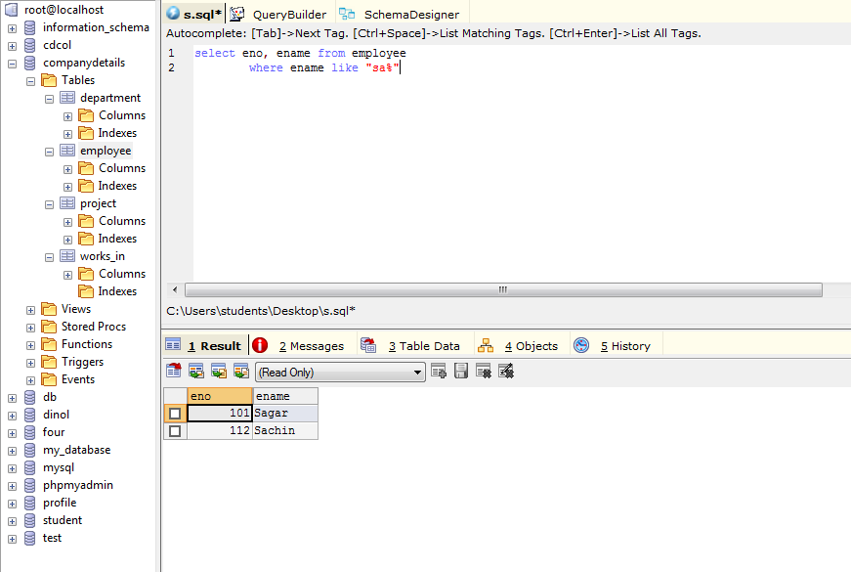

List all employee name with their project names.

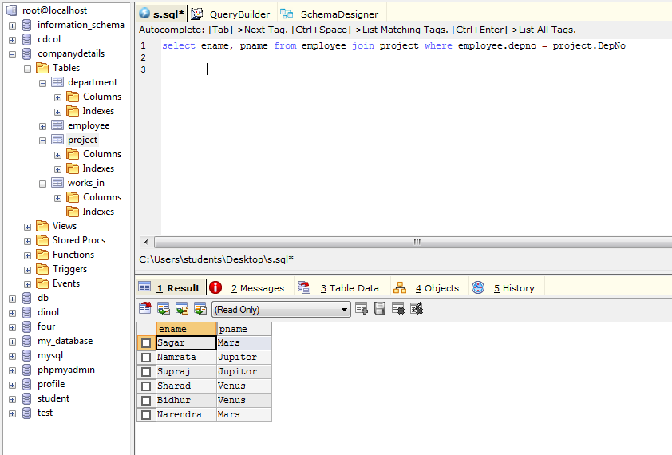

List name of all employees and their salary who are working in project Mars or Venus.

List name of all employee and their salary who are working in project earth and venus.

List name and address of all employees who work in department which is located in pokhara.